Lab 3
Implementing a firewall
Objective:
The purpose of this lab is for the student to understand basic features of and implement a firewall. Students will also utilize IOS commands and a GUI to explore and configure a Cisco firewall.
Diagram:
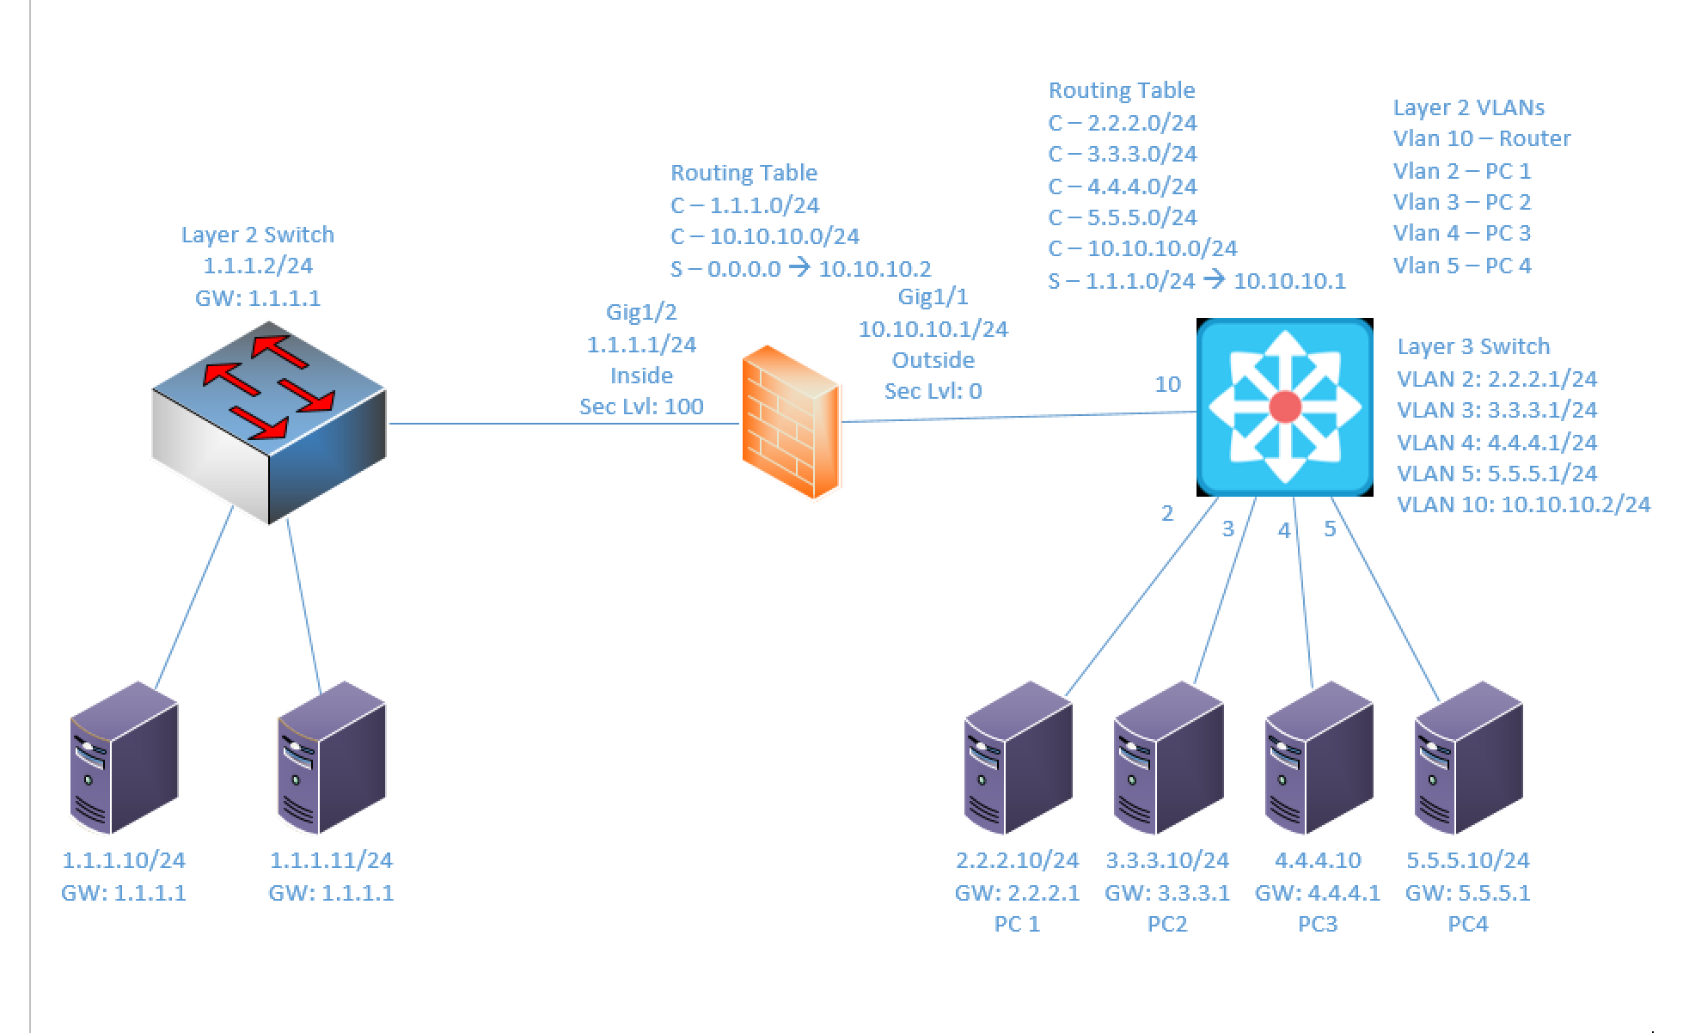
Components:
6 – PC’s
1 – Cisco 3650 Layer 3 Switch
1 – Cisco 3650 Layer 2 Switch
1 – Cisco 5516-X ASA Firewall

Useful commands for this lab:

show route – view ASA routing table
show interface ip brief – view status of ASA layer 3 interfaces
show nameif – view ASA interface names and security levels

Configure Firewall Interface

int gigabitethernet1/1
nameif outside
security-level 0
ip add 2.2.2.1 255.255.255.0
no shutdown

Specify ASDM Location

dir flash:
config terminal
asdm image flash:asdm-742.bin !choose an asdm image in the list from previous command
write mem !save configuration
reload !reboot firewall

Allow Web Access (HTTPS)

http server enable
http 1.1.1.0 255.255.255.0 inside

Configure SSL settings

ssl server-version tlsv1.2
ssl client-version tlsv1.2
ssl cipher tlsv1.2 fips

Procedure:
- Connect all PC’s together on the layer 3 switch and put their static IP addresses, subnet masks and gateways on them. Test connectivity by pinging each machine within the network.

- Using the diagram above, label the Layer 3 switches VLAN IP addresses and ports below
Layer 3 Switch VLAN Table
VLAN | IP | Switch Port
2 | 2.2.2.1/24 | 2
3 | 3.3.3.1/24 | 3
4 | 4.4.4.1/24 | 4
5 | 5.5.5.1/24 | 5
10 | 10.10.10.2/24 | 10

- Using the diagram above, label the routing tables for the Layer 3 switch and firewall below.
Routing Tables
Firewall | Layer 3 Switch
C – 1.1.1.0/24 | C - 2.2.2.0/24
C – 10.10.10.0/24 | C - 3.3.3.0/24
S – 0.0.0.0/0 -> 10.10.10.2 | C - 4.4.4.0/24
 | C - 5.5.5.0/24
 | C - 10.10.10.0/24
 | S - 1.1.1.0/24 -> 10.10.10.1

- Place the switch ports into the proper vlans. Configure all of the switches vlan IP addresses.

- Enable routing on the Layer 3 switch

- View the routing table on the Layer 3 switch

- Verify that the PC’s on the switch can ping each other

- Configure the IP addresses on the firewall’s interfaces, set the name of each interface and the security level, and turn on the interfaces.

  - What commands did you enter?
int gigabitethernet1/1
nameif outside
security-level 0
ip address 10.10.10.1 255.255.255.0
no shutdown

int gi1/2
nameif inside
security-level 100
ip address 1.1.1.1 255.255.255.0
no shut

- Enable http access to the firewall and allow the 1.1.1.0/24 network to access it from the inside interface. Make sure to configure SSL settings as well.

  - What commands did you enter?
http server enable
http 1.1.1.0 255.255.255.0 inside
ssl server-version tlsv1.2
ssl client-version tlsv1.2
ssl cipher tlsv1.2 fips

- Ping the firewalls inside interface from a machine on the 1.1.1.0/24 network and verify it is up and working.
- On a machine on the 1.1.1.0/24 network open a web browser (Internet Explorer) and connect to the URL https://1.1.1.1

- Select Run ASDM. Take all of the defaults and always allow access … eventually to will get to the ASDM Manager page.
- Select the configuration tab and under device setup select interfaces
- Verify the interfaces have the correct names, security levels, ip addresses and state
- Under device setup, select routing and then select static routes.
- Add the default route and select the outside interface. Click Apply when completed.
- Select the firewall tab. Click on NAT Rules.
- Add a rule that allows any source to any destination and uses the original address for everything. Apply the rule when completed
- Under the firewall select Objects and then network objects/groups.
- Add all 4 external networks (include subnet masks) with a name (Network_2, Network_3….) and a type of network
- Add servers 1 and 2 (Name Server_1 and Server_2) with their IP addresses and a type of host.
- Add a network Object group. Call the group name External_Networks and add the 4 external networks (Network_2, Network_3…)
- Add a network Object group. Call the group name Web_Servers and add servers 1 and 2 to the group.
- Select Service objects/groups.
- Select add and then a service group. Call the group Web_Services and add http and https (tcp ports 80 and 443)
- Click apply when finished.
- Under Firewall select Access rules. Under the access rule type at the bottom select IPv6 only.
- Right – Click and select Add IPv6 Access rule. Under Interface Any Deny Any to Any, service IP. Click OK when done.
- Under the access rule type at the bottom select IPv4 only.
- Right – Click and select Add Access rule. Under Interface Inside Permit Any to Any, service IP. Click OK when done.
- Right – Click and select Add Access rule. Under Interface Outside Permit Any to Any, service ICMP. Click OK when done.
- Right – Click and select Add Access rule. Under Interface Outside Permit External_Network to Web_Servers, service Web_Services. Click OK when done.
- Right – Click and select Add Access rule. Under Interface Outside Deny Any to Any, service IP. Click OK when done.
- Verify outside networks can ping Server 1 and 2.
- Highlight the outside rule deny any any and click the arrows to move it to the top of the list.
- Can outside networks ping the servers? Yes
- Click apply. Can outside networks ping the servers? No
  - Why? The ‘deny any any’ rule is now the highest priority so all traffic is dropped

- Move the rule back down to the end of the list and click apply. Verify the outside networks can ping the servers.
- Highlight the outside rule permit any any service icmp. Right click the rule and select edit.
- Change the destination from any to Web_Servers. Click OK and then Apply.
- Can the outside networks ping the servers? Yes
- Under objects select network object/groups and highlight the Web_Servers object.
- Select edit and remove Server 2 from the group members. Click OK and apply.
- Can the outside networks ping Server 1? Yes
- Can the outside networks ping Server 2? No
  - Why? We removed Server 2 from the Web_Servers group, so the firewall rule no longer applies and it cannot be pinged anymore

- What are some benefits of using groups (and grouping objects together)?
It reduces the time that it takes to create or change a configuration that applies to multiple interfaces since it eliminates the need to change every individual interface and re-type commands over and over.

- Create the lab diagram below (PCs, router Firewall and switch connections) in Packet Tracer or Visio. Label the IP addresses, subnet masks, and gateways used by each device. Label the routing tables next to the switch and router and the switches vlan IP addresses and port vlan information.

